Hello Parents!

Congratulations! You have signed your child up for Kindergarten, where the formal schooling adventures begin! We want your child to be fully ready for Kindergarten, so we have included a study packet for you and your child. Please work on this packet with your child over the summer. Below is a list of skills that your child should know/be with upon entering Kindergarten to ensure success.

Social Skills
- Can state first and last name.
- Use his/her words to tell an adult if something is wrong.
- Tell an adult when he/she needs help.
- Independently use scissors appropriately.
- Can take care of basic needs independently (bathroom, blow nose, button, zip, dress self).
- Can take turns and share.
- Can follow one and two step directions the first time.
- Can follow rules/routines.
- Can hold a pencil and crayon correctly.
- Understand the concepts of safe vs. unsafe behaviors.
Remember, social skills support all areas of academics and are very important!

Reading/Writing
- Talk about familiar stories (The Three Little Pigs, common nursery rhymes, etc.).
- Recognize environmental print (McDonald’s “M”, Disney logo, stop signs, etc.)
- Be exposed to a variety of books (Nursery Rhymes, Eric Carle, books with rhyme and repetition).
- Be familiar with the parts of a book (front cover, back cover, etc.)
- Know how to hold a book and turn the pages correctly.
- Recognize a difference between uppercase and lowercase letters.
- Can write his/her name (beginning with a capital letter and spelled correctly).
- Recognize a word versus a letter.
- Sing the ABCs.
The most important thing you can do to support these reading and writing skills is to read and discuss books with your child!

Math
- Can recognize numbers 0 through 10.
- Can orally count numbers 1 through 10.
- Can touch and count objects up to 5.
- Can tell what number comes next after a given number.
- Can recognize basic shapes and colors.
- Can recognize simple patterns.
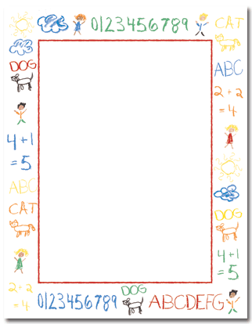
- Has a basic understanding of measurement.
(When given a picture of a giraffe and a dog, your can tell you the giraffe is taller than the dog.)
Enjoy your summer!
We look forward to seeing you and your kindergarten student soon!

Let’s Make Getting Ready for Kindergarten Fun!
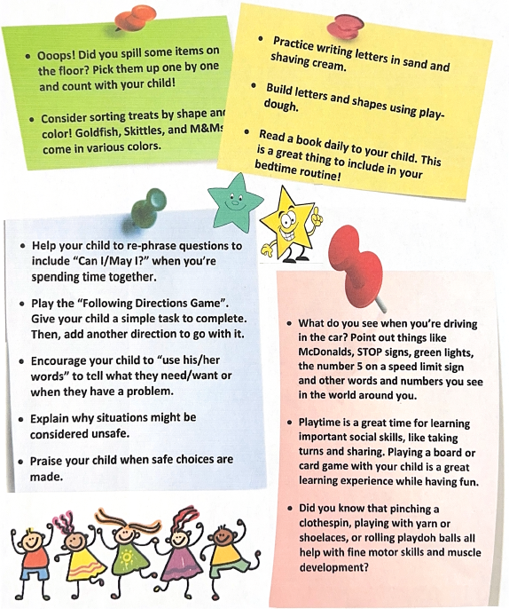
Student’s learn in many waysand opportunities for learning are everywhere! You can learn during a ride in the car, as you’re eating a meal, or even as you’re reading before bedtime! Here are some ideas to get your child thinking like a Kindergartener!

