
Otis A. Mason Elementary School
207 Mason Manatee Way
St. Augustine, FL 32086
Phone 904.547.8440 Fax 904.547.8445
http://www-mes.stjohns.k12.fl.us/

Dear Parent/Guardian,

Your student will take the computer-based Grade 4 or 5 Benchmarks for Excellent Student Thinking (B.E.S.T.) Writing assessment on March 31. The B.E.S.T. Writing assessment is administered in one 120-minute session, and students may work up to half of a typical school day. You will be provided information about how to see your student’s results after testing is completed.

You or your student can review the computer-based sample items and certain released tests at home at https://flfast.org/families.html.

Please review the following policies with your student before testing:
- Electronic Devices—Students are not allowed to have any electronic devices, including, but not limited to, cell phones, smart glasses, and smartwatches, at any time during testing or during breaks (e.g., restroom), even if the devices are turned off or students do not use them. Students may not wear smart glasses during statewide testing, even if they are prescription glasses. Students with prescription smart glasses will need to remove them or test another day with standard glasses. If your student is found with an electronic device or is found using Bluetooth/wireless headphones/earbuds during testing, his or her test will be invalidated (not scored).
- Testing Rules Acknowledgment—All tests include a Testing Rules Acknowledgment that reads: “I understand the testing rules that were just read to me. If I do not follow these rules, my test score may be invalidated.” Prior to testing, test administrators read the rules to students, and students click a box in the test to show that they understand the testing rules.
- Discussing Test Content after Testing—The last part of the testing rules read to students states that because the test content is secure, students may not discuss or share details about the test items and passages after testing. This includes texting, emailing, or posting test content to social media sites. While students may not share information about what questions were on their test, this policy is not meant to prevent students from talking about their testing experiences with their parents/families.
- Working Independently—Students are responsible for doing their own work during the test and for protecting their answers from being seen by others. If students are caught cheating during testing, their tests will be invalidated (not scored).
- Leaving Campus—If your student leaves campus before completing a test session (e.g., for lunch, an appointment), he or she will not be allowed to return to that test session. If your student does not feel well on the day of testing, it may be best for him or her to wait and be tested on a make-up day. Please remember not to schedule appointments on testing days.
- Testing Accommodations—If your student has an Individual Educational Plan (IEP), a Section 504 Plan, or is an English Language Learner (ELL) or a recently exited ELL, please contact the school to discuss the testing accommodations that will be provided for your student.
- Testing Irregularities—If a testing irregularity occurs in your student’s testing room, as part of a school investigation, your student may be asked questions to provide information about the incident.
- Extra Time—Any student still working at the end of the allotted time for the session will be provided extra time, as allowed, to complete the test. However, based on directions from the district, students who are not actively working (e.g., sleeping) at the end of regular time may be dismissed rather than being given extra time.

If you have any questions related to this test administration, you may contact Julie Hudson, Assistant Principal at 904-547-8443 or Julie.hudson@stjohns.k12.fl.us.

For more information about the Florida Statewide Assessments program, please visit the portal at https://flfast.org/fsa.html.

Thank you for supporting your student and encouraging him or her to do his or her best on the test.

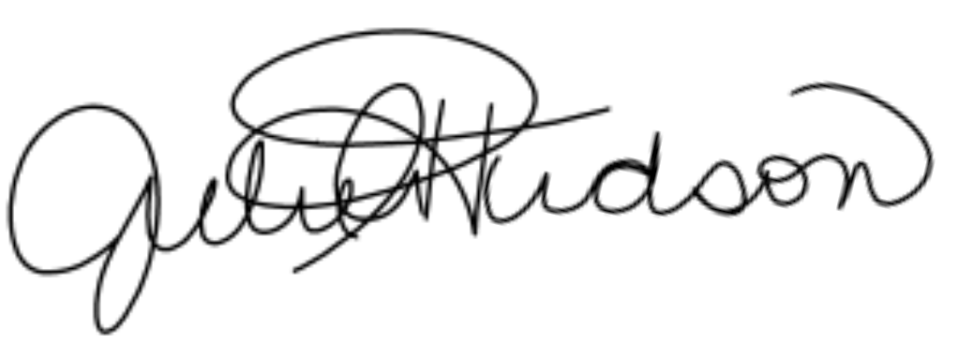
Sincerely,

Julie A. Hudson
Assistant Principal

