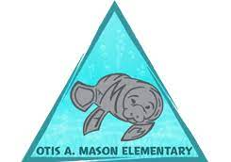
OTIS A. MASON ELEMENTARY SCHOOL
School Advisory Council Agenda
January 18th 2024 3:30-4:20

Call to Order* 3:30

Review/Approval of Previous December 14th 2023 Minutes 3:32-3:35

Financial Report- Kim Edwards 3:35-3:40

- New Science Adoption-Ryan Zimmerman 3:40-3:45

- School Support Organization – Devin Schieder & Alice Flores 3:45-3:50

- Parent & Teacher School Survey- All Members 3:50-4:00

Principal Updates- Mrs. Keaton 4:00-4:20

Tightened Budgets 24 – 25

NN and OO opening in 24/25 Staffing

Budget meetings coming soon

Dr. Mason’s Services

Substitutes

Space Camp

Cooking Club

New Testing Cut Scores

TOY/RTOY Banquet

Chick-Fil-A Spirit Night

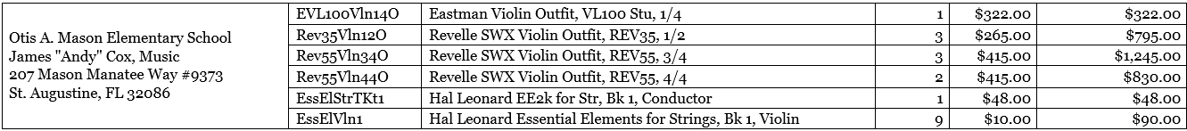

Meeting Adjourned 4:20
Upcoming School Events:
January 22nd PTO Meeting
January 22nd – 26th Celebrate Literacy Week
January 25th Jump Rope for Heart Kick Off!
January 30th Spirit Night @ Panda Express
February 6th Interim Reports Issued
February 9th Kiss Dance
February 15th SAC Meeting

